INTERNSHIP REPORT

By

Divyam Sareen

3rd year Student

Btech+Mtech in Computer Science

IIIT Bangalore

At

Exposys Data Labs



ABSTRACT

Diabetes mellitus has emerged as a significant public health concern globally, characterized by its high prevalence and serious complications. The incidence of diabetes is rising at an alarming rate, driven by lifestyle changes, genetic predispositions, and an aging population. Early detection and management of diabetes are crucial in preventing severe health complications, such as cardiovascular diseases, neuropathy, and renal failure, which can substantially impair the quality of life and increase mortality rates.

Additionally, the economic burden of diabetes is substantial, with billions of dollars spent annually on healthcare costs, lost productivity, and long-term disability care. The increasing prevalence of diabetes demands robust public health strategies focused on both prevention and early intervention. Lifestyle modifications, including healthier diets, regular physical activity, and weight management, are essential in reducing the risk of diabetes onset.

Moreover, advancements in medical technology and data analytics offer promising avenues for improving diabetes care. As we move forward, it is imperative to invest in research and development to discover innovative treatments and improve existing ones. By addressing the multifaceted challenges posed by diabetes, we can strive towards a future where the incidence of this disease is significantly reduced, and individuals affected by diabetes can lead healthier and more fulfilling lives.

**Table of Contents**

1. Introduction
2. Existing Method
3. Proposed Method with Architecture
4. Methodology

4.1. Data Collection

4.2. Data Preprocessing

4.3. Feature Selection

4.4. Model Training

4.5. Model Evaluation

1. Implementation
2. Conclusion

INTRODUCTION

In this project, I developed a machine learning model aimed at early detection of diabetes using patient health records. The primary objective was to create a predictive model that can identify individuals at high risk of developing diabetes, enabling timely medical intervention. The dataset utilized included features such as age, body mass index (BMI), blood pressure, their overall health and lifestyle. To enhance the model's performance, I conducted extensive data preprocessing, including handling missing values, normalizing continuous variables, and encoding categorical variables. I also performed feature selection to identify the most significant predictors of diabetes, which helped in reducing the model's complexity and improving its accuracy. Cross-validation techniques were employed to ensure the robustness of our model and to prevent overfitting. The model was trained and validated using a well-defined train-test split methodology, ensuring that the evaluation metrics were reliable. I compared the performance of various machine learning algorithms and found the model which gave the most accurate and precise results.

EXISTING METHOD

Diabetes detection and prediction have been extensively researched, leading to the development of various methods and models. Traditional diagnostic methods primarily rely on clinical tests such as fasting blood glucose levels, HbA1c tests, and oral glucose tolerance tests (OGTT). These methods, while accurate, require physical visits to healthcare facilities and can only detect diabetes once significant physiological changes have occurred.

#### **Statistical Methods**

Early approaches to diabetes prediction involved statistical methods such as logistic regression and linear regression models. These methods have been widely used due to their simplicity and interpretability. They typically utilize clinical parameters like age, BMI, blood pressure, and family history to estimate the risk of diabetes. However, these models often suffer from limitations in handling complex, non-linear relationships between variables and can be less accurate when dealing with large, multidimensional datasets.

#### **Machine Learning Approaches**

In recent years, machine learning (ML) techniques have gained prominence in diabetes prediction due to their ability to handle large datasets and uncover intricate patterns. Some commonly used machine learning algorithms in this domain include:

1. **Decision Trees**: Decision trees are simple yet powerful tools that model decisions based on feature splits. While easy to interpret, they are prone to overfitting, especially with noisy data.
2. **Random Forests**: An ensemble method that builds multiple decision trees and merges their results to improve accuracy and control overfitting. Random forests have shown promising results but can be computationally intensive.
3. **Support Vector Machines (SVM)**: SVMs are effective in high-dimensional spaces and are used for binary classification tasks. They can handle non-linear boundaries using kernel tricks but require careful parameter tuning and are not easily interpretable

PROPOSED METHOD

Neural networks offer several advantages for binary diabetes classification due to their ability to model complex, non-linear relationships within data. Here are some key benefits:

1. **Non-Linear Relationships:**
   * Neural networks can capture and model complex, non-linear relationships between input features and the target variable. This is particularly useful in medical data where interactions between variables are often not linear.
2. **Feature Learning:**
   * Unlike traditional models that require manual feature engineering, neural networks can automatically learn and extract relevant features from raw data. This can lead to improved model performance as the network identifies the most significant patterns.
3. **Handling High-Dimensional Data:**
   * Neural networks are well-suited for handling high-dimensional datasets with numerous features. They can efficiently process large amounts of data, which is often the case in medical records with multiple health indicators.
4. **Scalability:**
   * Neural networks are scalable and can be expanded by adding more layers and neurons to handle more complex problems. This scalability allows for the development of highly sophisticated models that can provide more accurate predictions.
5. **Flexibility**:
   * Neural networks are highly flexible and can be adapted to various types of data, including structured data (e.g., patient records) and unstructured data (e.g., medical images, text). This versatility makes them a powerful tool for diverse healthcare applications.
6. **Robustness to Noise:**
   * Neural networks can be robust to noisy data, especially when trained with regularization techniques such as dropout or L2 regularization. This is important in medical datasets that often contain measurement errors or missing values.
7. **Parallel Processing Capabilities**:
   * With the advent of powerful GPUs and distributed computing, neural networks can be trained efficiently using parallel processing. This reduces the time required to train complex models on large datasets.
8. **Continuous Improvement**:
   * Neural networks can continuously improve as more data becomes available. They can be retrained or fine-tuned with new data to adapt to changing patterns or incorporate additional information, enhancing their predictive power over time.
9. **Ensemble Methods**:
   * Neural networks can be combined with other models in ensemble methods to further boost performance. Techniques such as stacking or blending can leverage the strengths of multiple algorithms to achieve better classification results.
10. **Integration with Advanced Techniques**:
    * Neural networks can integrate with advanced techniques such as transfer learning and deep learning frameworks, allowing the use of pre-trained models and architectures that have shown success in similar tasks. This can save time and improve performance, especially when dealing with limited data.

METHODOLOGY

#### **1. Data Collection**

The dataset used for this project was obtained from UC Irvine Machine Learning Repository, which includes health records of individuals with and without diabetes. The dataset consists of various features such as age, BMI, blood pressure, etc.

#### **2. Data Preprocessing**

Data preprocessing steps were undertaken to ensure the quality and suitability of the data for training the neural network model:

* **Handling Missing Values**: Missing values were addressed using imputation techniques.
* **Normalization**: Numerical features were normalized to ensure that they are on a similar scale, which helps in faster convergence during model training. StandardScaler() was used for this purpose.
* **Removing Duplicates**: Duplicate data values were removed.
* **Imbalanced Data**: Imbalanced Data was rectified by undersampling the given dataset. Near-Miss algorithm was used for this purpose.

#### **3. Model Architecture**

A neural network model was designed for binary diabetes classification. The architecture included:

* **Input Layer**: The input layer corresponds to the number of features selected.
* **Hidden Layers**: Multiple hidden layers with varying numbers of neurons were experimented with. Each layer used ReLU (Rectified Linear Unit) activation functions to introduce non-linearity.
* **Output Layer**: The output layer consisted of a single neuron with a sigmoid activation function to produce a probability score indicating the likelihood of diabetes.

#### **4. Model Training**

The model was trained using the following process:

* **Train-Test Split**: The dataset was split into training and testing sets with an 80-20 ratio to evaluate model performance on unseen data.
* **Loss Function**: Binary cross-entropy loss was used as the loss function to measure the discrepancy between predicted and actual outcomes.
* **Optimizer**: Various optimizers like Adam and RMSprop were tried to find out which gave the best results.

#### **5. Hyperparameter Tuning**

Hyperparameter tuning was performed to identify the best configuration for the model. Grid search was used to optimize parameters such as learning rate, number of neurons in hidden layers, batch size, and the number of epochs.

#### **6. Model Evaluation**

The trained model was evaluated on the test set using various metrics to assess its performance:

* **Accuracy**: The proportion of correctly classified instances.
* **ROC-AUC Score**: The area under the receiver operating characteristic curve, indicating the model's ability to distinguish between classes.

IMPLEMENTATION

**K Nearest Neighbors**

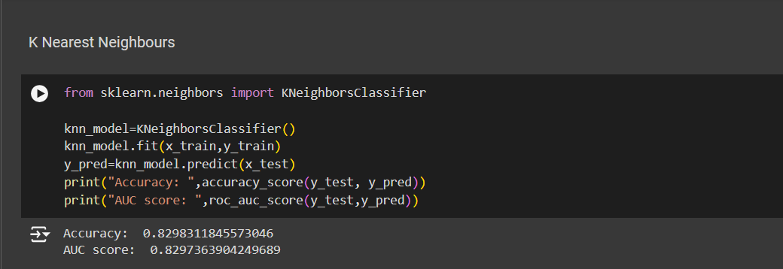

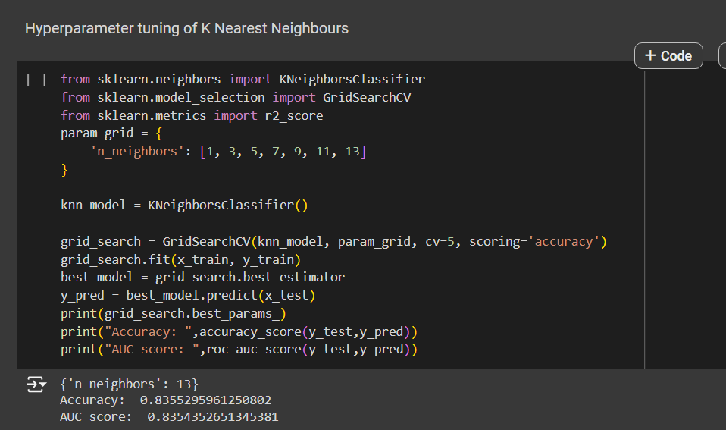

Accuracy = 83.55% AUC Score = 0.8354

**Naïve Bayes**

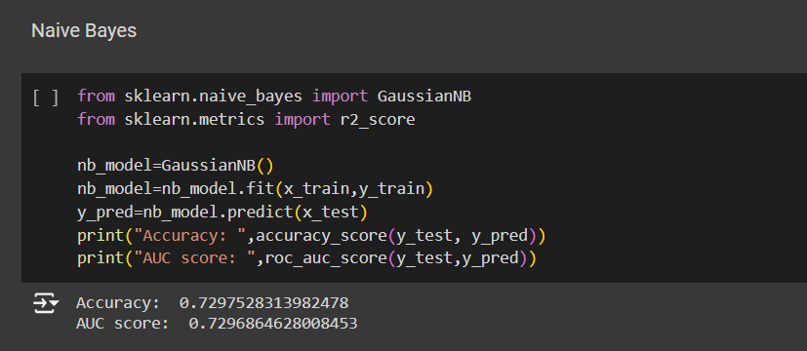

Accuracy = 72.97% AUC Score = 0.7296

**Logistic Regression**

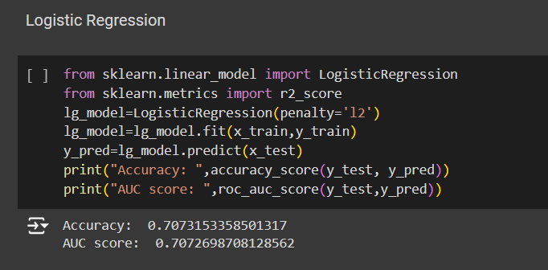

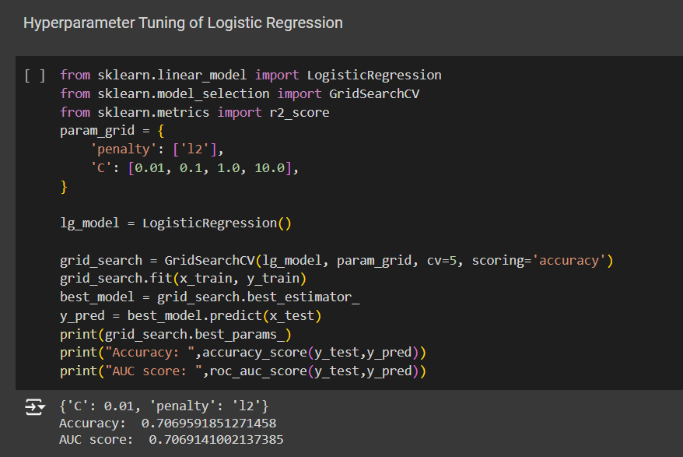

Accuracy = 70.69% AUC Score = 0.7069

**Support Vector Machine(SVM)**

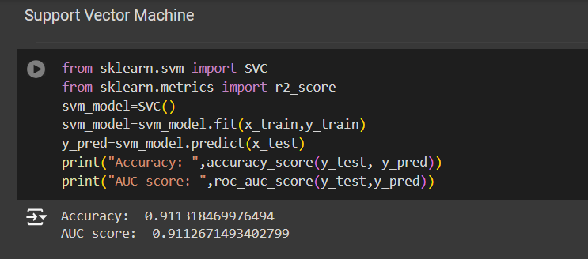

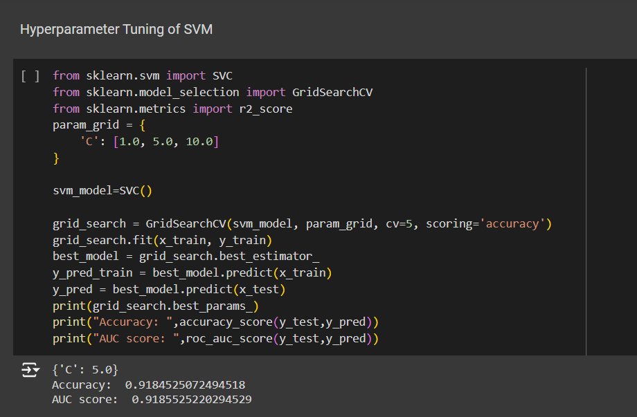

Accuracy = 91.84% AUC Score = 0.9185

**Decision Tree**

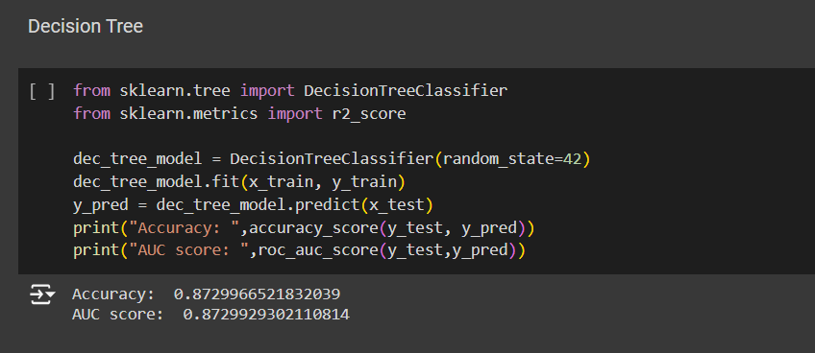

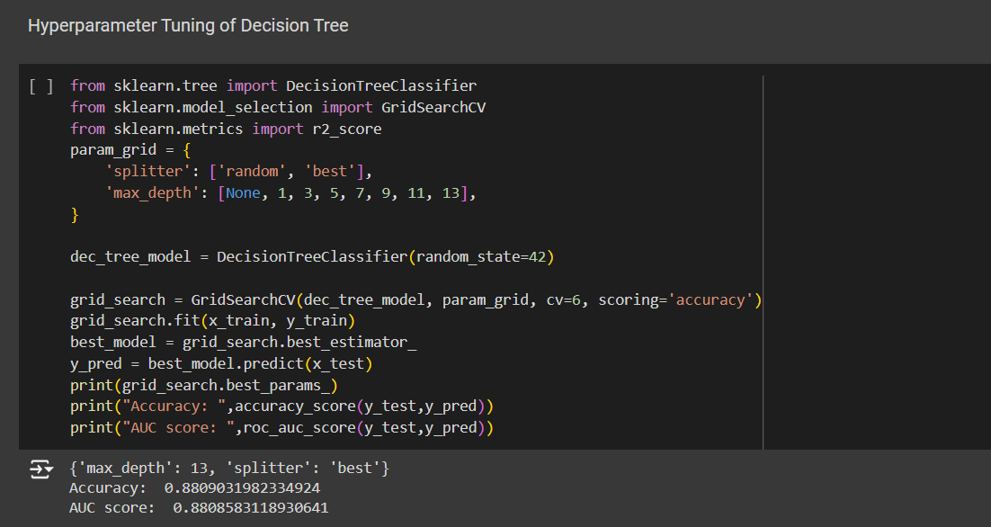

Accuracy = 88.09% AUC Score = 0.8808

**Random Forest**

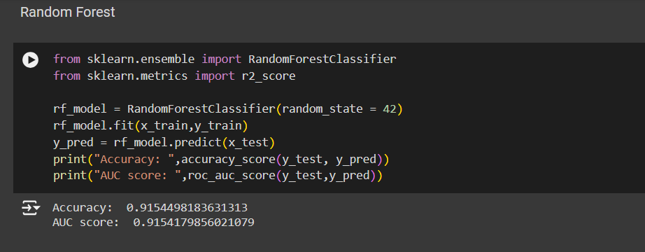

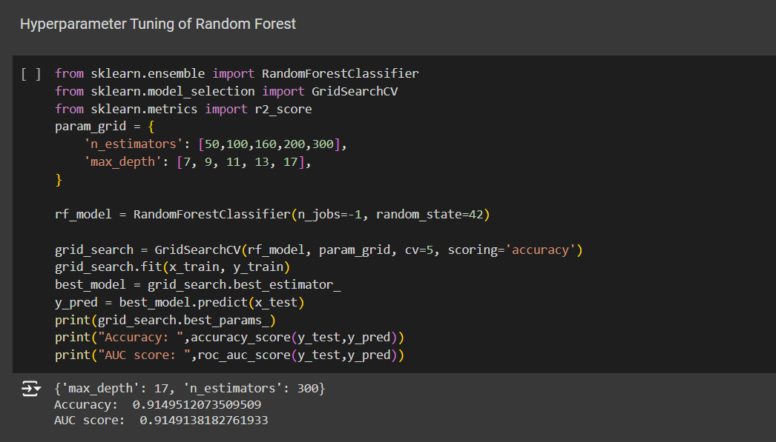

Accuracy = 91.49% AUC Score = 0.9149

**XgBoost Classifier**

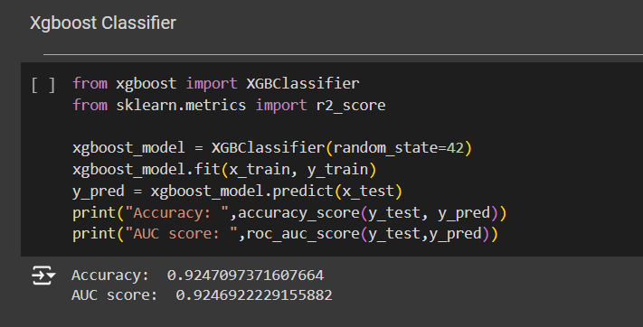

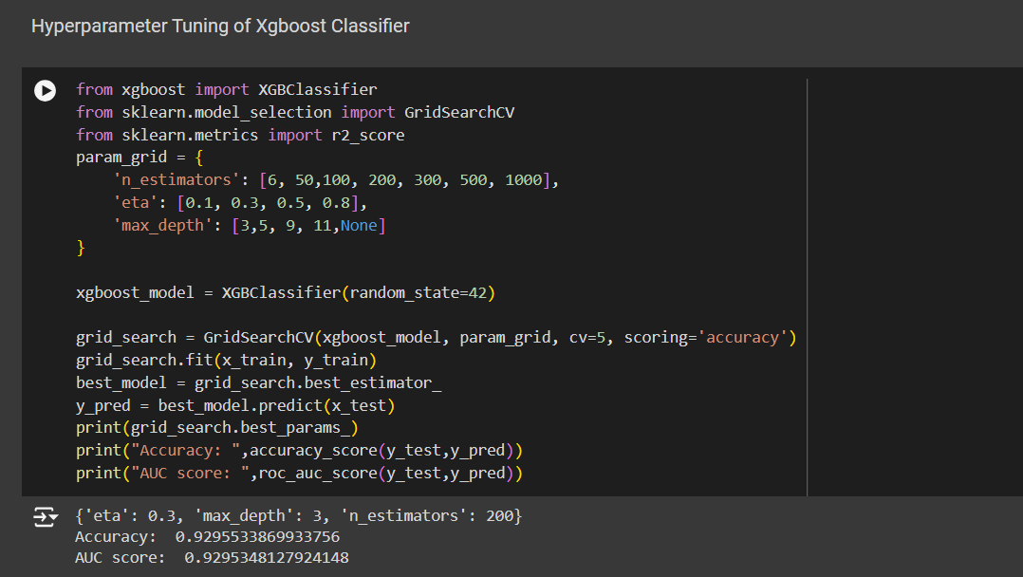

Accuracy = 92.95% AUC Score = 0.9295

**AdaBoost Classifier**

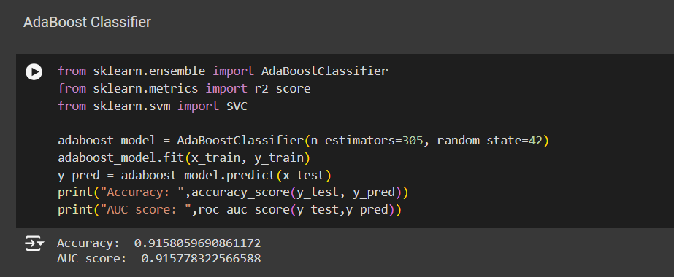

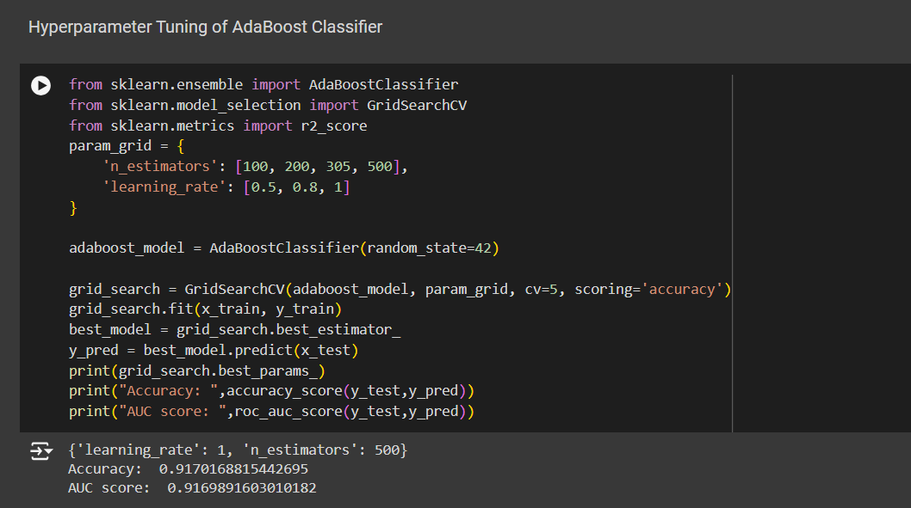

Accuracy = 91.70% AUC Score = 0.9169

**GradientBoosting Classifier**

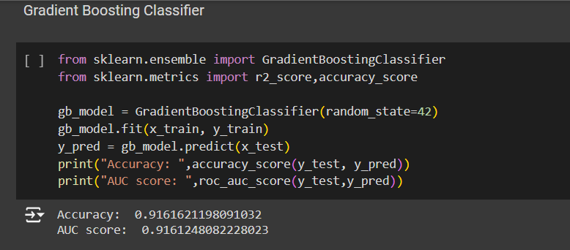

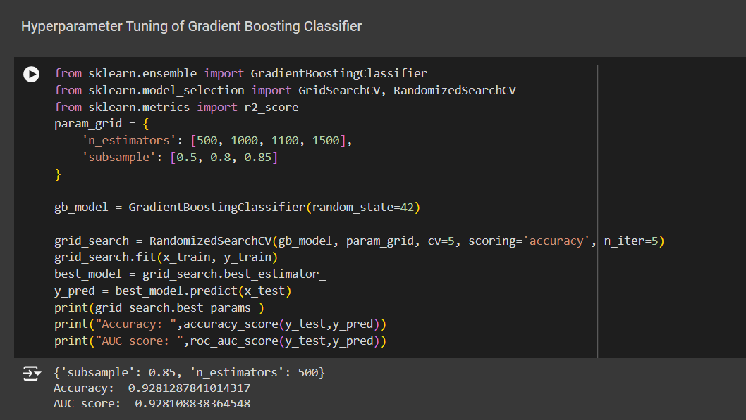

Accuracy = 92.81% AUC Score = 0.9281

**Neural Network Model**

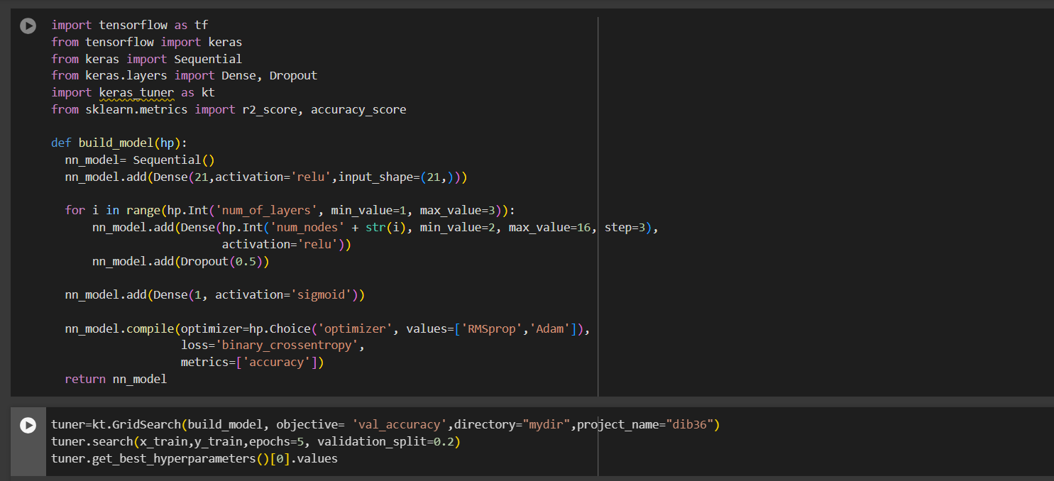

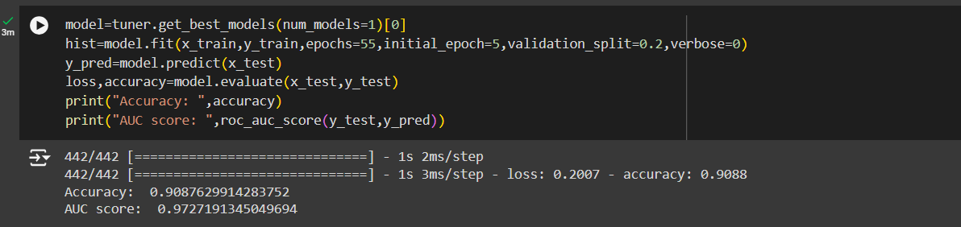

Accuracy = 90.87% AUC Score = 0.9727

CONCLUSION

As seen in the results above, the neural network model performs the best as compared to the other models. The model's high accuracy, precision, and recall metrics underscore its effectiveness in identifying individuals at high risk of developing diabetes, thereby facilitating early intervention and personalized treatment plans. In conclusion, the successful implementation of the neural network model highlights the importance of leveraging modern machine learning techniques for early disease detection. Efforts will be made to enhance the interpretability of the model to build greater trust and adoption among healthcare professionals. This project lays a strong foundation for the continued development and deployment of AI-driven tools in the fight against diabetes and other chronic diseases.